SWIMMING

The Swimming Section hires two indoor pools near Barnwood for exclusive use by Section Members. These provide excellent facilities at highly competitive rates for regular swimming away from the general public.

We have three sessions each week throughout the year (excluding public holidays):
- Tuesday & Friday lunchtimes 12.40 – 13:10 at Sir Thomas Rich’s School (meet at the central entrance/exit doors at 12.20 to organise lift shares).
- Tuesdays evenings 21:00 - 21.30 at Brockworth School

The pools at Sir Thomas Rich’s and Brockworth are 20 and 25 metres long respectively. Typically 5 - 12 swimmers attend each session.

Membership is open to all Members and Associate Members of the EDF Energy (Barnwood) Sports & Social Club. Our membership year starts on 1st October and the Section subscription for 2013/14 is £75 (for 12 months) or £44 (for 6 months). To enable you to join at any time, the Section Treasurer will be happy to agree a rate for any other period of membership. Alternatively, Members and Associate Members of the S&SC are very welcome to swim on an occasional basis as Guests for £3.00 per session.

For a free trial swim please us the ‘Contact Us’ for the attention of:
Martin Brook (Swimming Section Chairman)
Aidan Rose (Treasurer), or
Chris Eley (Secretary)

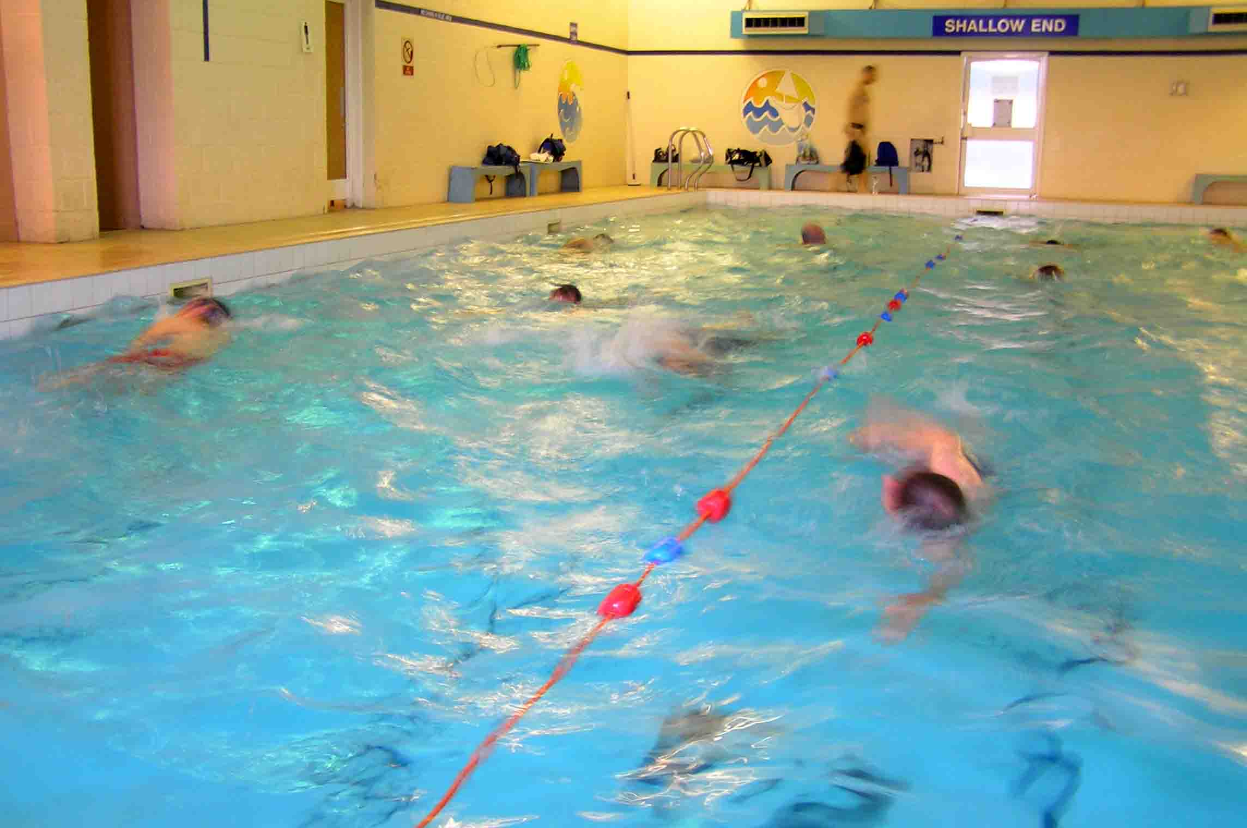

You’ll be more than welcome!

Why not come and join us?

