SAT 17th AUG LEIGH SINTON, BLUEBELL POOL – With café serving cooked food from 9am
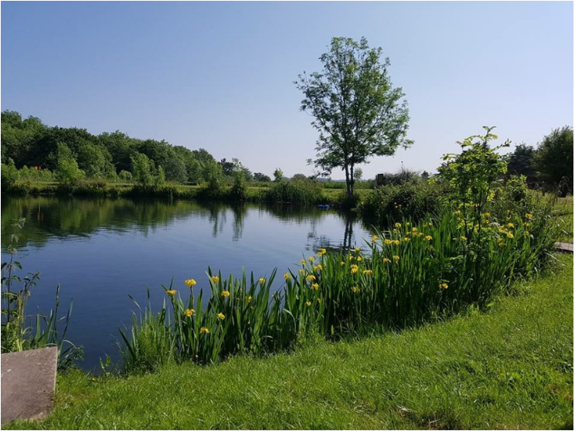
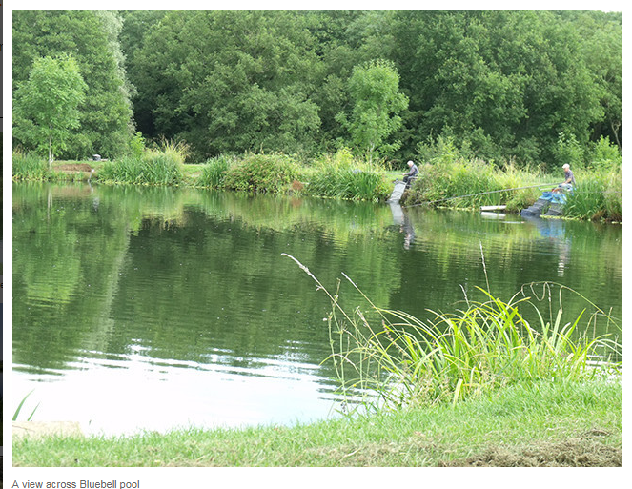
The pool nearest to the cafe and car park, the 23-peg Bluebell Wood Pool was the first of the Leigh Sinton waters to be opened for fishing and paved the way for the development of the other waters as the fishery became increasingly popular with both pleasure and match anglers.
Bluebell Wood is bowl shaped with up to 20 feet of water being found in the centre and as much as six feet just a rod length out with the water gradually deepening the further out you go.
Its depth has an advantage as it enables the fish to grow to a decent size and although the average stamp of mirrors and commons is in the 3lbs to 4lbs range, fish up to 23lbs have been caught in this pool.
Stocked mainly with roach to 2lbs, tench and a reasonable head of carp, Bluebell Wood Pool also holds chub to 5lbs and perch to 2lbs. It usually fishes better in the margins with the most popular pegs being by the overflow pipes. For some reason it tends to fish harder the further out you go.
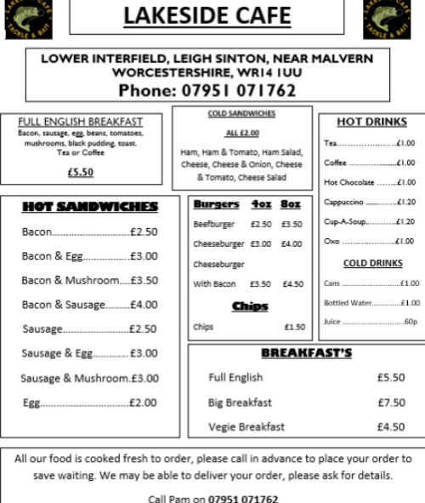
Existing stocks were supplemented over the 2008/2009 winter with the addition of good numbers of six to eight inch tench and bream.
A good all-round silver fish pool, particularly for those who have not fished Leigh Sinton before, Bluebell Wood is usually much murkier in colour than the other waters, particularly when the large fish circle around bed of pool grubbing in the bottom for food.
Anglers after the roach use pole or traditional rod-fished float techniques either high in the water or on the bottom. Many of the bigger fish tend to come from the deep parts of the water, so sliding float or legering is often worth a try.
When it comes to baits, maggots and casters are good all-round baits with casters being particularly effective for the roach and chub. Because boilies and other high-protein baits are not allowed, carp anglers tend to use meat, sweet corn or trout-pellet paste on the bottom. However, anglers should note that floating baits are not allowed. Another highly successful bait is worm. Ever since it opened, Bluebell Wood has been one of Leigh Sinton's most popular match waters
Lake side café
Food can be pre-ordered, we could have a slightly later start and have a breakfast before the match?

Rules

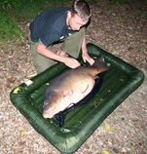
Fish Handling and Unhooking.
When visiting the fishery can you please ensure that you do not start fishing until you have set up your landing net. Anyone fishing without a landing net will be asked to leave the fishery.
Where possible please use an unhooking mat when handling the fish. These are available at the tackle shop at reasonable prices. Anyone mistreating the fish will be asked to leave the fishery.
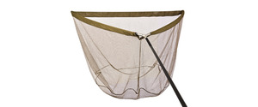Please do not start fishing if you do not have a landing net.
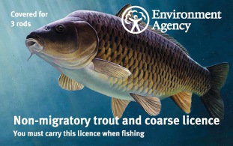Please ensure you have a valid EA Licence
Please follow these few simple rules when visiting the fishery.
All anglers should be in possession of a valid EA license.
Please purchase your day ticket before you start fishing, if this is not possible please get your ticket as soon as the cafe or tackle shop is open. There is a £2 surcharge for any money collected on the bank.
Keep nets not allowed for pleasure anglers.
All nets to be dipped in the tanks provided.
Barbless hooks only maximum size 6.
No fish are to be taken from the venue.
Opening times 7.30 am till 9.30 pm or dusk whichever
is the sooner.
Night fishing by syndicate membership only.
No litter to be left.
Under 14 have to be accompanied by a responsible adult.
No floating baits.
A single pint of hemp per session is allowed.

Ground bait is allowed but please use responsibly.

No nut baits.
Notes.
Please be aware that bailiffs make regular checks on all pools.
Tickets can be purchased from either Lakeside Tackle & Bait, Lakeside Café or from the payment machinelocated in the car park (Coinage only).
All farm gates will be locked at 9.30 or at dusk, whichever is soonest, please ensure that you are ready to leave before then.

